7146 Test plan evaluation

# Clarity:

The plan does not list all test cases and a detailed explanation on expected inputs and results; however, test samples listed did provide enough information to implement in JUnit.

# Coverage:

The tests suggested do cover most of the issues with the code; however, they were too extensive to implement. The test suite ended up having more than 40 individual tests.

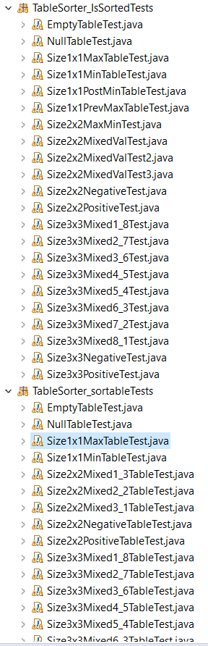It’s important to mention that I thought tests for 3x3 matrices were not going to make a difference on the results, but they ended up catching the sorting issues that 2x2 matrices did not catch for the sortable() method.

Only a single program breaking issue was missed by the tests recommended. The issue produced by passing a null parameter into either isSorted() or sortable() methods. It does state that the code should return a “NullPointerException” in that case, but it does not specifically mention if try and catch statements should be required to handle the error. In this case, the code does return the exception expected, but the programmer calling the method is not required to wrap the method call in a try/catch statement because of a lack of a “throws” statement. This results in an unhandled exception.

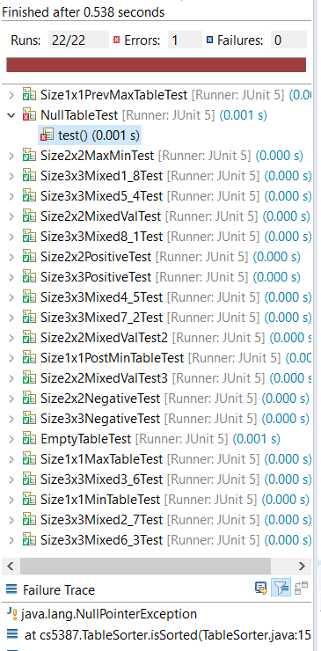

# Invalid Test Cases

The test plan description suggested to create testcases where an array of characters or doubles would be passed to the method that creates the table object. This was not possible to implement as it would not compile.

The cases also listed a test for a matrix of size MAXINTxMAXINT which cannot be implemented due to the resources needed to run such test.